Accessibility Guide for The Galson Estate Trust Business Centre
office@uogltd.com , www.galsontrust.com
Contact for accessibility enquiries: office@uogltd.com and 01851 850 393
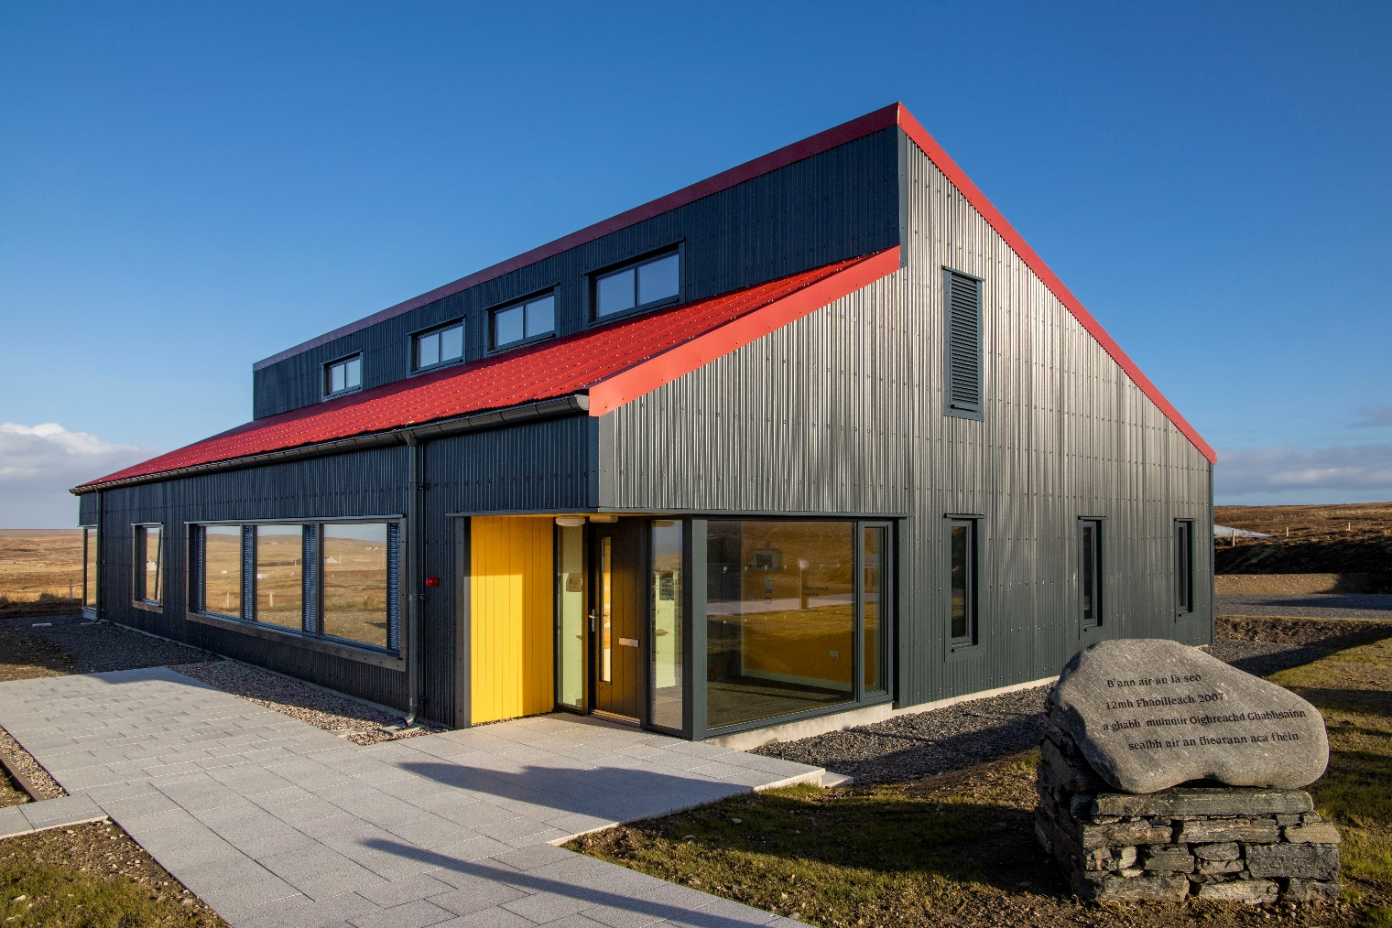

Welcome | Failte
The Galson Estate Trust Business Centre is the main operations base for Galson Estate Trust staff. The building has a public exhibition on community land ownership, hosts local events, and has toilet facilities.
This building is open to the public between the hours of 9am – 5pm Monday – Friday.
The facilities both within the Galson Campsite and the Urras Oighreachd Ghabhsainn Business Centre are accessible for wheelchair users. We also offer a hearing loop in our Business Centre.

At a Glance

Level Access
- The main entrance of the Urras Oighreachd Ghabhsainn Business Centre has level access. There is level access from the main entrance of this building to:
  - Exhibition area
  - Two accessible toilets, one with accessible shower.

Level access rooms
- The main entrance door of the Urras Oighreachd Ghabhsainn Business Centre is 800mm wide or more.
- The accessible toilet doors within the Urras Oighreachd Ghabhsainn Business Centre are 910mm wide or more. One toilet has a level access shower.

Hearing
- We have a hearing loop in the Urras Oighreachd Ghabhsainn Business Centre.

Getting here
Urras Oighreachd Ghabhsainn
Business Centre
Tom Na Ba
South Galson
HS2 0SH

Travel by public transport
- You can reach the principal town of Stornoway by ferry and plane. The Galson Campsite and the Urras Oighreachd Ghabhsainn Business Centre is situated in the community of Ness, approximately 30 minutes’ drive from Stornoway town centre.
- The W1/W1A bus serves the Ness – Stornoway route. There is no bus stop, but the bus will stop when requested; let the driver know in advance that you wish to disembark at Tom na Ba. Please be aware there is no bus shelter and no pavement, and the bus will drop you on a very busy road (60mph). The bus will stop approximately 150m from the Galson Estate Trust Business Centre and approximately 200m from the Galson Campsite facilities.

Travel by taxi
- You can get a taxi with Ness Taxis by calling 07768522758.

Parking
- We have a car park at the Urras Oighreachd Ghabhsainn Business Centre where we have two accessible parking spaces and one drop off space. There is a kerb with an incline of 40mm.
- The parking is less than 50 metres from the main entrance and is tarmacked. Parking is free.
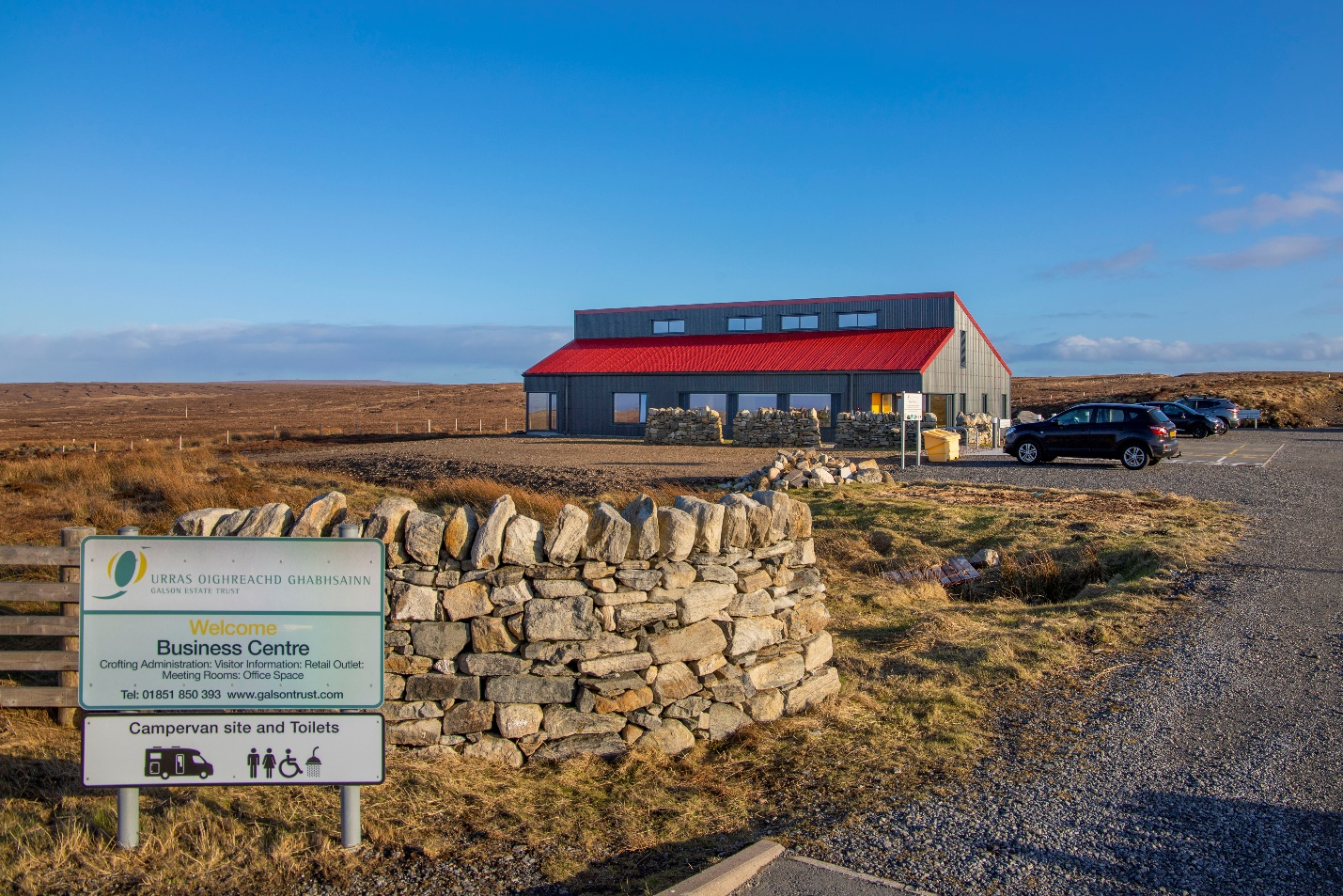
- From the car park to the main entrance of the Urras Oighreachd Ghabhsainn Business Centre, there is level access.
Business Centre from road view.

Arrival

Main entrance
- The main entrance of the Urras Oighreachd Ghabhsainn Business Centre has level access.
- There is a lip on the threshold of the doorway.
- The door is 860mm wide.
- The main door is side hung and manual.
- There is then an inside door that is manual, and side hung. It is 920mm wide.
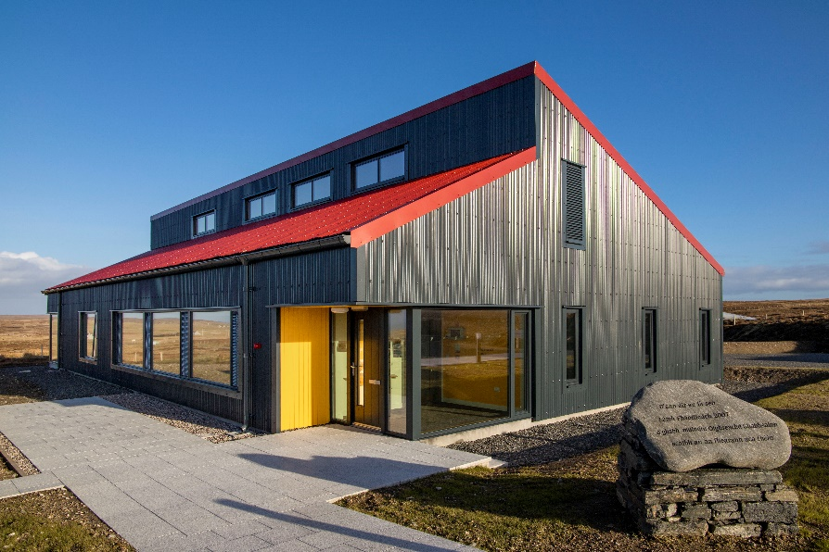

Path to Business Centre entrance
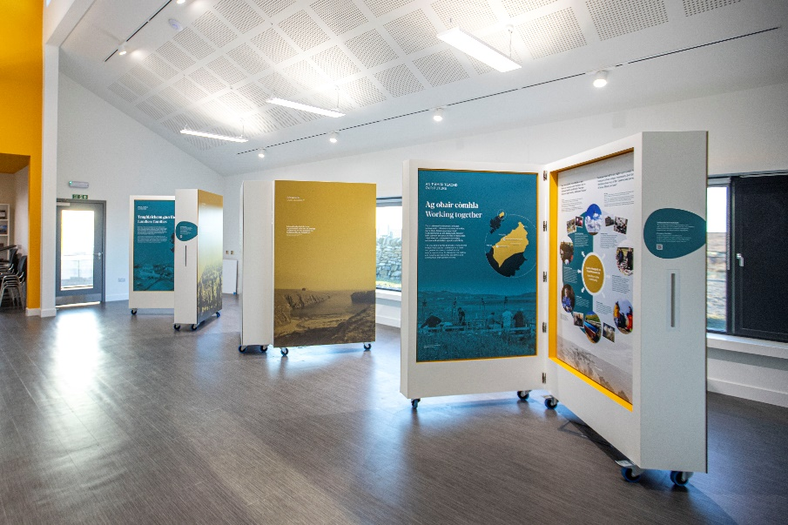

Inside entrance and exhibition space

Accessible toilet
- The accessible toilet door is 910mm wide and opens outwards
- The bathroom has a level access shower. There is a shower chair available. The level access shower has handrails.
- The toilets have handrails. The direction of transfer onto the toilet is to the right.
- The toilet seat is 480mm high.
- The taps are lever operated. There is space under the basin, with no pedestal or boxing.
- The shower head can be lowered to 1470mm from the floor if required.
- There is a changing table within the accessible toilet.
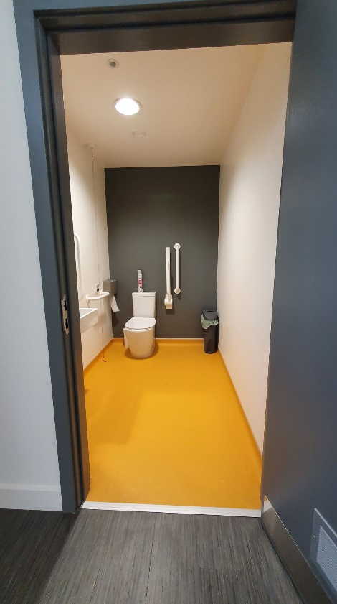
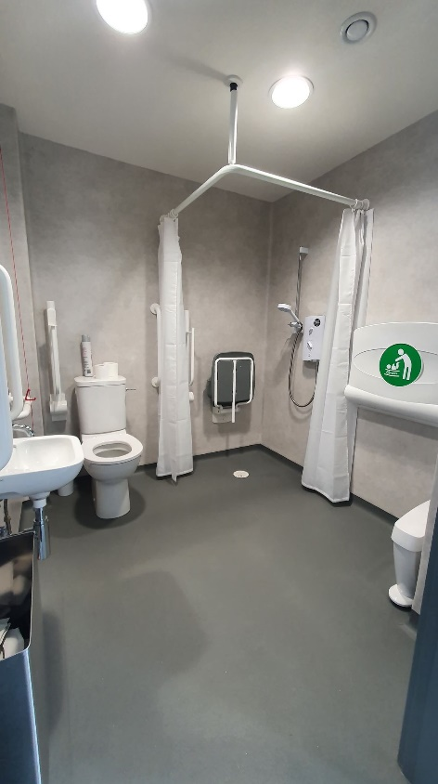

Getting around outside
- There is paving from the front of the building to the back door of the Business Centre.

Customer care support

Accessibility equipment
- The nearest toilet area for assistance dogs is located anywhere within the perimeter of the Urras Oighreachd Ghabhsainn site.
- Hebridean Travel offer wheelchair accessible transport with up to five additional seats. Contact information – 01851 701111 or bookings@hebcab.co.uk.

Emergency evacuation procedures
- In an event of an emergency staff will assist you to our assembly point.

Customer care support
- WiFi is available: UOG Guest – UrrasG21

Guide last updated: 22 August 2022

