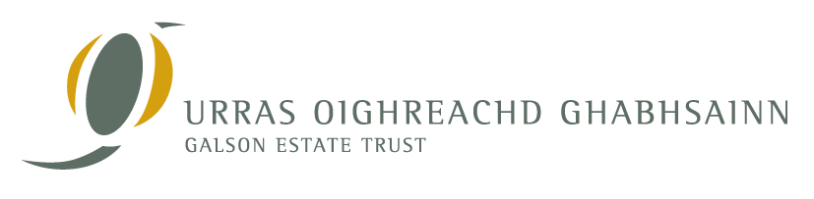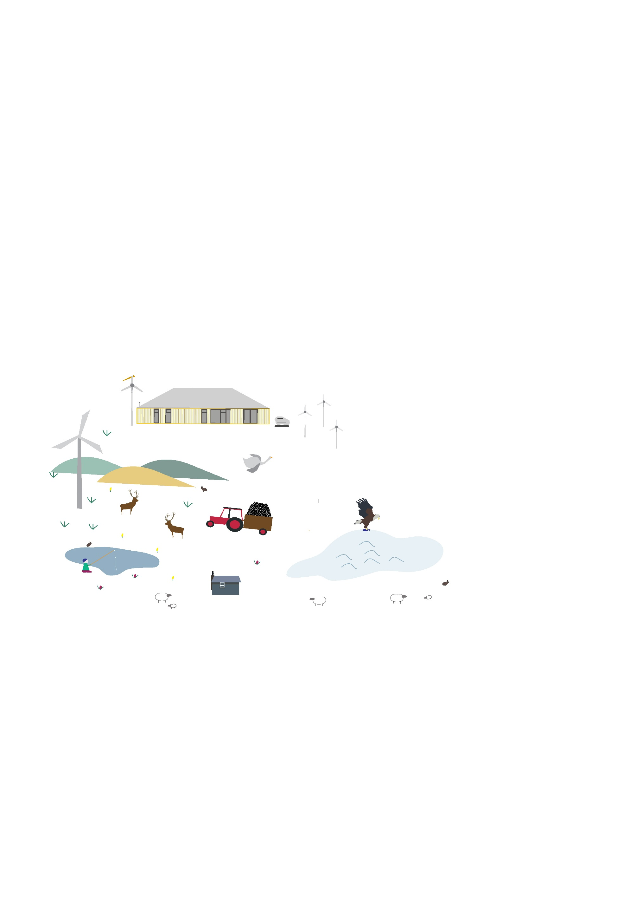

The Galson Estate Trust (Urras Oighreachd Ghabhsainn) is entrusted with the management of the 56,000 acre, community owned Galson Estate covering the majority of North Lewis. North Lewis is a beautiful and important place for natural, built and social heritage with unique interactions between crofting lifestyles, beautiful landscapes and a diverse natural environment.

Do you reside outwith the Galson Estate but have a special attachment to North Lewis or the Urras, or do you live in the area but want to support local development and sustainable environmental management.

The ‘Friend of Galson’ membership provides a vital role in supporting work of Urras, helping Urras to achieve its aims and objectives. **Why not join us.**

As a ‘Friend of Galson’ you will receive:

°  10% discount for Urras events and workshops

°  An annual newsletters posted to your home

°  An Urras Oighreachd Ghabhsainn Calendar

or Teatowel

°  E-mail updates

Simply fill in the ‘Friends of Galson’ Expression of Interest form on the back of this slip and return to the Urras Oighreachd Ghabhsainn. The recommended donation is £20 per annum or £2 a month (minimum)

**BECOME A ‘FRIEND OF GALSON’**

Recruiting new members and providing ongoing benefits for existing members is a vital part of Urras’ work. It is very important for the trust to grow, helping to ensure a vibrant engaged community.



**Expression of Interest Form**

**‘Friends Of Galson’**

I would like to receive more information about becoming a ‘Friend of Galson

**NAME**:……………………………………………………………..…..……………………………………………………..

**ADDRESS:** ……………………………………………………...……….……...............................................

**POSTCODE**:..…………………………………………………………………................................................

**TEL NO:**………………………………………………………………...……………………………………………………

**EMAIL**:…………………………………………………………………………………………………………………………

You will automatically be added to our mailing list, to opt out please tick here 🞏



**For more information contact us:**

Address: UOG Business Centre, Tom na Ba, South Galson, Isle of Lewis, HS2 0SH

Tel: 01851 850393

E-mail: office[@uogltd.com](mailto:amy@uogltd.com)

Website: [www.galsontrust.com](http://www.galsontrust.com)